**Statistics for Goal Net website:**

General page of games information:

Selecting games by different parameters: Teams, Winner, Season (as a dropdown)

Page for teams’ statistics:

Dividing the page into leagues – a table for each league. For each team displayed as a record:

Total number of plays, total number of wins, total number of goals.

SELECT   
 gp.Team_ID,  
 gp.Name,  
 gp.Total_Games,  
 COALESCE(w.Total_Wins, 0) AS Total_Wins,  
 goals_count_table.total_goals  
FROM   
 (  
 SELECT   
 Teams.Team_ID,  
 Teams.Name,  
 COUNT(Games.Game_ID) AS Total_Games  
 FROM   
 Teams  
 LEFT JOIN (  
 SELECT Home_Team_ID AS Team_ID, Game_ID  
 FROM Games  
 UNION ALL  
 SELECT Away_Team_ID AS Team_ID, Game_ID  
 FROM Games  
 ) AS Games ON Teams.Team_ID = Games.Team_ID  
 GROUP BY   
 Teams.Team_ID,   
 Teams.Name  
 ) AS gp  
LEFT JOIN   
 (  
 SELECT   
 Games.Winner_ID AS Team_ID,   
 Teams.Name,   
 COUNT(*) AS Total_Wins   
 FROM   
 Games  
 INNER JOIN   
 Teams ON Teams.Team_ID = Games.Winner_ID  
 GROUP BY   
 Games.Winner_ID,   
 Teams.Name  
 ) AS w ON gp.Team_ID = w.Team_ID  
 LEFT JOIN   
   
 (SELECT Goals.Team_ID, count(*) as total_goals  
from Goals  
group by Team_ID)  
AS goals_count_table ON gp.Team_ID=goals_count_table.Team_ID;

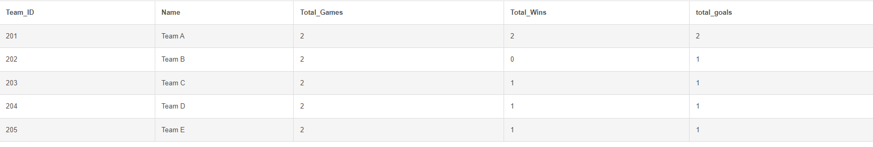

*** in Goals: change player_ID to User_ID? שיהיה אחיד לטבלת עבירות

Page for players’ statistics:

After selecting a team(?):

A table displaying the number of goals per player (for all possible games- from goals table only)

select Players.User_ID, Players.Full_Name, count(*) as Total_Goals  
from   
Players inner join Goals  
on Players.User_ID = Goals.Player_ID  
Group by Players.User_ID,  
Players.Full_Name;

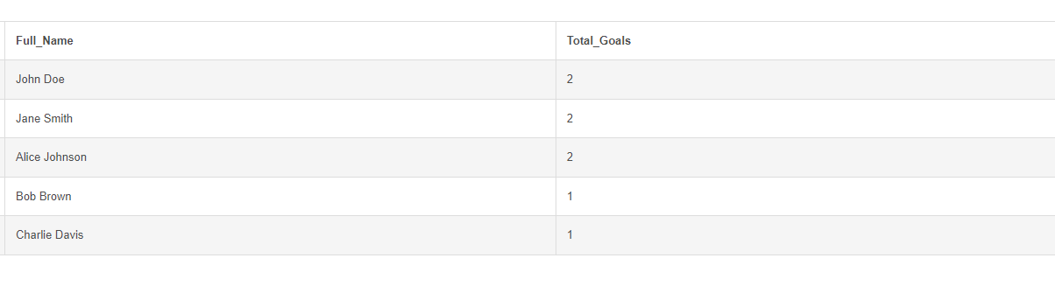

A table displaying the number of penalties per player (for all possible games- from Penalties table only):

select Players.User_ID, Players.Full_Name, count(*) as Total_penalties  
from  
Players inner join Penalties  
on Players.User_ID = Penalties.User_ID  
Group by Players.User_ID,  
Players.Full_Name;

A table displaying the number of goals a certain player scored during a specific game (dropdown. Joining Goals table + Games table + Players table)

A table displaying the number of penalties a certain player got during a specific game (dropdown. Joining Penalties table + Games table + Players table)

Displaying players by their position (dropdown – players table)